

RealEstateCore procurment design requirements for building automation

|  |  |  |  |
| --- | --- | --- | --- |
| **systems Date** | **Version** | **Author** | **Comments** |
| June 9th, 2022 | 1.0 | Erik Wallin et al | Machine translated based on Swedish version. |

**Contents**

1. Background and purpose 4

1.1. Introduction RealEstateCore 5

2. RealEstateCore coding of data points 6

2.1. Data points - "tag list" 6

2.2. Data types to expose 6

2.3. Location - Spatial representation of data points 7

2.4. Service areas 7

2.5. Sampling and transmission frequency 7

2.6. Requirements for storage of observations 7

3. Technical requirements for API 8

3.2. Override 8

3.3. Fail-over 9

4. SLA - Service Level Agreement 9

4.1. Up-time 9

4.2. Setting time 10

4.3. Upgrades 10

5. IT security 10

6. Ownership data and GDPR 10

7. Definitions and RealEstateCore concepts 11

8. Appendices and references 12

# Background and purpose

The purpose of this document is to be able to set requirements for compatibility with RealEstateCore (REC) in procurement and the implementation of various technical property systems, both in new production and in conversions of existing properties to be able to ensure that data from the systems can be accessed to other IT systems and that it is possible to control the systems and thus the property via external applications. Technical property systems refer to superior control systems (SCADA, BMS - Building Management System, BAS - Building Automation System) that control substations (PLC) and / or fieldbus-based systems (Modbus, BACnet) and IoT systems (mqtt , https). This document continues to use the terms BMS, PLC, IoT system and external IT system as part of a technical property system.

This document does not prescribe:

* How to select or configure PLC
* Which fieldbuses to use
* Which BMS to select
* Which systems for elevators, passage or IoT to select.
* How to mark components on drawings or in BMS and PLC.

This document is primarily aimed at subcontractors such as technical consultants, system suppliers, property managers, project developers, purchasers, project managers and installation consultants.

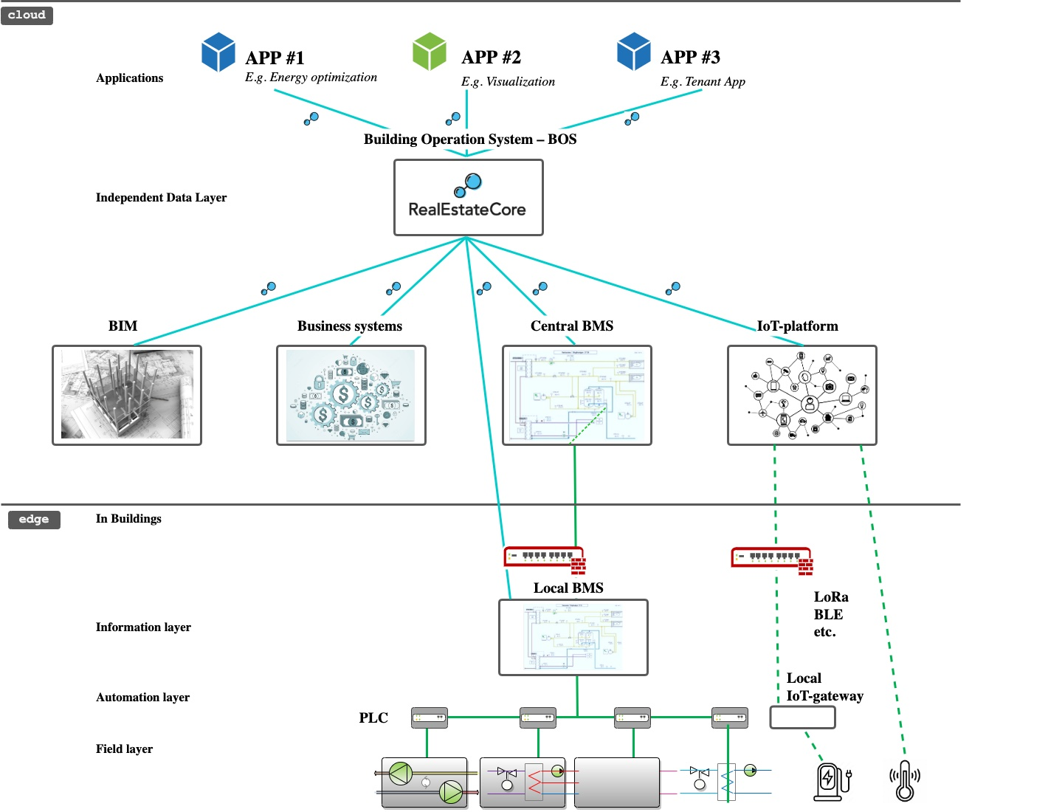

*Figure 1. Overview of system architecture for technical building systems.*

## Introduction RealEstateCore

RealEstateCore is a standardized way of naming and categorizing property data that makes it possible to compare different buildings' information with each other and standardizes communication from different technical property systems and external IT systems. This creates opportunities for advanced data analysis, intelligent control and monitoring of buildings as well as visualization of property data in e.g. 3D models.

RealEstateCore is an open standard that is free to use at no cost, with no restrictions or licensing requirements. All actors such as architects, property owners, property managers, system suppliers and construction contractors, etc. can use the RealEstateCore standard to similarly describe the interaction, data reading and central control of several different properties in an external IT system.

The content of RealEstateCore is not entirely new but is based in part on existing standards that are applied with a pragmatic approach to finding the least common denominator. In this way, the gap between different existing industry standards is bridged.

RealEstateCore focuses on connecting and bridging four different domains for standards:

* Digital representation of the building design elements (eg BIM / IFC)
* Control and operation of the building (eg Brick Schema, Belok object definitions, Haystack)
* IoT technology (e.g. SSN, WoT)
* Business data for processes and agreements (e.g. CDM / IBPDI)

Read more about RealEstateCore:https://www.realestatecore.io

# RealEstateCore coding of data points

## Data points - "tag list"

A tag list is the list of all devices (system components) and its sensors (sensors) and actuators (actuators) as a superior system (e.g. EcoStruxure) exposes to an external IT system.

* + 1. The tag list must be able to be exposed and exported from a parent system in RealEstateCore format.
    2. The tag list must contain a selected subset of all available data points for the property's appliances, sensors and actuators that can be read and controlled.

## Data types to expose

Which data points are to be selected to be exposed to external IT systems differ from different properties and property owners.

Data points to be included in exposure and export, see Appendix 1. "RealEstateCore tag selection".

## Location - Spatial representation of data points

Devices, sensors and actuators in the building must be spatially placed in reference to a model of the building (in a BIM model or dwg drawing) and handled by placing the data point in a named building part (eg room number, building number or floor plan) or that the coordinates in a coordinate system (for example from the drawings) are specified.

## Service areas

Which rooms or zones are served by a device (for example an air handling unit) must be described according to RealEstateCore.

See Appendix 1: “RealEstateCore tag selection” for examples.

## Sampling and transmission frequency

Depending on different areas of use, requirements are set for how often and how quickly an observation should be forwarded to an external IT system.

* + 1. Event-controlled transfer is to be recommended, ie. that when a value changes, it is passed on. In the case of event-controlled transmission, there must be adjustable parameters for the minimum and maximum time of the transmissions.
    2. For polling transmission, adjustable parameters for sampling frequency and transmission frequency must be available for different types of data points.
    3. Recommendation for sampling frequency:
       1. Presence detection: Directly at event
       2. Temperature: 15 minutes
       3. Energy: 15 minutes
       4. Power: 1 minute (need for faster measurement may occur)
       5. Alarm: Direct at event
    4. Recommendation for transmission to external IT system is that it should take place directly in connection until the observation is made but no longer than one (1) minute delay.

## Requirements for storage of observations

In the event of a communication interruption between a technical property system and an external IT system, values ​​must be stored in a technical property system for at least up to 168 hours in order to be automatically transferred when communication is restored.

Requirements for storing data in PLC or IoT systems are not included in this set of requirements.

# Technical requirements for API

Technical property systems that expose data and override functionality must use RealEstateCore's API standard.

* + 1. RealEstateCore API version 3.3 must be used.
    2. The parent system should expose observations and actuation characteristics in messages according to the RealEstateCore specifications, ie. be able to search, read and write data.
    3. Data from sensors must be readable via the RealEstateCore API (e.g. air quality meter, energy meter, water meter, presence sensor, position indication, weather station, etc).
    4. Actuators must be able to be read and actuated via the RealEstateCore API (eg valves, dampers, motors, passage / lock, lighting, etc).

For technical documentation of REST and streaming API, see: https://www.realestatecore.io/resources/

## Override

By override is meant the function of being able to change parameters for control from an external IT system (for example to be able to achieve power reduction of electricity, heating or cooling). This means that technical property systems must be able to be influenced (overridden) in a controlled and safe manner.

* + 1. Safety functions for technical property systems must be taken into account so that they are not overridden in the event of oversteer.
    2. A property technician must be able to switch on and off the possibility of external override in the technical property system's user interface.
    3. The status of the override (eg Active) must be visualized in the user interface for real estate technicians.
    4. Examples of data points and functions that can be overridden:
       1. Individual setting and parallel displacement of control curves for ventilation systems, heating and cooling circuits.
       2. Switch on and off, and when possible, to regulate speed or degree of opening of motors, pumps, dampers, shunts etc.
       3. Switch on and off - and when it is possible to regulate - strength and color for lighting.
       4. Switch on and off - and when it is possible to regulate - the degree of opening for sun protection.

## Fail-over

In the event of a disturbance or interruption in the communication between the technical property system and the external IT system, control functions must return (fail-over) to operating mode as in case of over-control deactivated. A control value must be prevented from becoming constant due to communication interruptions.

* + 1. Technical property systems must be able to regulate in the event of a malfunction in communication to an external IT system that causes over-control to disappear or go beyond set limits (for example due to loss of communication).
    2. Technical property system must check that external IT system is active and within set limits with adjustable time interval. It must be possible to select the time interval for control between 1 minute and 60 minutes.
    3. A property technician must be able to manually turn on and off override via a user interface for a technical property system.

# SLA - Service Level Agreement

This set of requirements for SLA is focused on the implementation and use of RealEstateCore for technical property systems.

The full requirements for SLA must be adapted to the property owner's needs.

SLA shall be established with suppliers of technical property systems and external IT systems where the following are taken into account:

## Up-time

What need for a degree of availability on different parts of systems is needed for data transfer to an external IT system?

*Footfall sensors for visitor counting for retail can have high demands on availability, while data for infrequent reports can be disconnected for a long time without negative impact.*

## Setting time

Different setting time requirements for restoring measures are required for different systems.

*For example, short set-up time for access systems and elevators while a climate sensor in an office room can be remedied at planned service times.*

## Upgrades

The technical property system's use of the RealEstateCore API must be continuously updated to follow the development of the RealEstateCore standard. For principles for updating the RealEstateCore standard, see: https://www.realestatecore.io/memberpage/

# IT security

This requirement is focused on the implementation and use of RealEstateCore for technical property systems. Full requirements for IT security are submitted to IT security experts.

General recommendations:

* All data traffic must take place with encrypted internet standards that are adapted to each property owner's conditions and established principles.
* NEVER send passwords or security keys for systems by email.
* Avoid service login accounts (eg "admin") for access to various systems. Accounts must be personal.

# Ownership data and GDPR

This set of requirements is focused on the implementation and use of RealEstateCore for technical property systems. Full requirements for how ownership of data and GDPR are to be implemented are submitted to lawyers.

Good to know is that the person who collects data / data is always responsible for handling that data, at all levels. The general recommendation is therefore that property owners always retain ownership and control of the use of all data created in various technical systems and that this is regulated in agreements.

# Definitions and RealEstateCore concepts

For specification of the use of RealEstateCore concepts, and dictionaries to find the right concept to use, see https://doc.realestatecore.io/3.3/full.html

For a visualization of RealEstateCore, WebVOWL can be used: https://doc.realestatecore.io/3.3/webvowl/index.html#full Device

|  |  |
| --- | --- |
| Often | several different sensors and / or actuators that together create a function. For example, an air handling unit. |
| Actuator | An actuator, motor or other thing that can be affected. |
| BMS | Building Management System, see Technical property system. Can also be called BAS (Building Automation System). |
| Operating system | The unit or system that serves a consumer. For example, an air handling unit that serves a room. |
| BIM | Building InformationModeling is usually done in the IFC format. |
| External IT system | System that is connected to a technical property system. For example, a cloud-based platform, a so-called Building Operating System (BOS). To create a data warehouse independent of the underlying system. |
| Property technician | A person who uses a technical property system to handle the technical operation of a property. |
| HMI | Human Machine Interface. Usually a graphical interface on a web page or in a smartphone application. |
| IoT | Internet of Things. Collective name for connected sensor technology. |
| Observation | A reading of a value. For example, a temperature. |
| PLC | Programmable Logic Controller. |
| REC | RealEstateCore.https://www.realestate.core.io |
| SCADA | Supervisory control and data acquisition. A system that controls one or more underlying systems. Often with a graphical interface. Often used synonymously with HMI or parent system. |
| Tag | list A list of the ID for various sensors and actuators in a technical property system or PLC. |
| Technical property | system System that brings together several systems (BMS and PLC). Often has a graphical user interface. |
| Override | To influence the control in a PLC or in a technical property system from an external IT system. Examples of this are controlling ventilation or influencing the heat supply to e.g. achieve better energy efficiency. |

# Appendices and references

|  |  |
| --- | --- |
| **Appendix no.** | **Designation** |
| 1 | RealEstateCore tag selection |
| Visualization | https://doc.realestatecore.io/3.3/webvowl/index.html#full |